Session 3

# The Rolling Fortress

The group is on the second floor of the fortress. All raiders except Vanco are dead

## Characters

### Vanco the Wraith

A man in a long dark hooded jacket. He has half a face blown and showing bone. He carries a well-crafted sword and a pistol.

## The Fortress

This thing is like a moving fortress. Four tank treads carry the structure and a huge engine powers it, belching steam. The building creaks as it moves.

### 1: Garage

Destroyed from engine.

### 2: Engine Room

Destroyed from engine.

### 3: Guard’s Quarters

This room has 9 beds and at the foot of each is a chest.

* Door to R1

### 4: Chief’s Room

As cobbled together as everything here is, this room was built with a higher level or ornateness and care. It contains a large bed, a dresser and a trophy case with an artifact.

* Door to R9

*Loot: 3 shins, Mind Imager*

### 5: Kitchen

A room with an oven, stove, and other cooking stuff. Inside is a chef who just looks like a raider with a chef’s hat, because why not.

* Door to R8

### 6: Bathroom

It’s a bathroom.

* Door to R8

### 7: Living Area

Oops, forgot to add it.

### 8: Grand Hall

This is the largest room in the building. In the center of this room is a large table surrounded by eclectic chairs.

* There are 3 doors and stairs to R1.
  + Door to R5
  + Door to R6
  + A locked door leads to stairs to R9
* A fight here will attract the chef in the kitchen

### 9: Helm

The front of the fortress has a curved viewing dome. It’s a mosaic of different kinds of glass from different wrecks. In the middle of this viewing area is a large wooden wheel attached to a control panel of levers and buttons. In this room are a helmsman who will continue to steer the ship indifferent to what’s going on, and Vanko the Wraith.

* There are stairs going down to R8
* There is a door to R4

**Encounter:**

**Vanko the Wraith LV4**

Health: 20

Damage: 5

Armor: 2

Movement: short

### 10: Workshop

Destroyed from engine.

# The Seed Vault

## Strange Tracks

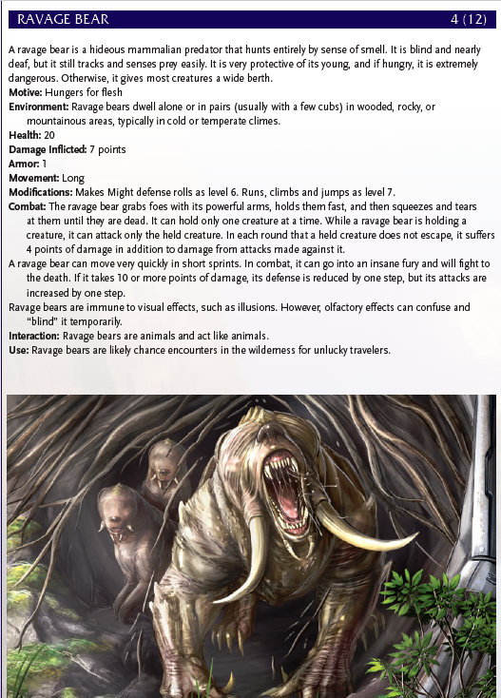

## Journey to the Mountains

Reaching the Door is a three-day journey. During one day, the Party is set upon by broken hounds.

Encounter

**Broken Hound (x7) LV2**

Health: 6

Damage Inflicted: 4

Movement: Short

* Perception at LV5 due to scent
* Four to six of them can concentrate on one foe and make one attack as if they were a level 4 creature, inflicting 8 points of damage.
* If numbers reduced to 4 they flee

At the door, Hunik thanks them for protecting him and continues on his way into the mountains.

## A Door in the Mountainside

Beside the door is a device. Placing things in front of it causes a green light to scan over it. The machine has a leaf symbol and will only activate if presented with a plant. When activated, the massive door in the mountains opens, revealing a darkened staircase down into the earth that extends far beyond human sight.

## Inside the Vault

### 1: Entrance Room

As the party reaches the bottom of the stairs, glowing blue fungus begins to light their way. Most of the entrance room is covered in these blue mushrooms, mostly on the walls and ceiling. There are a couple of carts in the corner of the room with a green bar on the front of them.

* If the fungus is touched, anyone in the room is attacked by a level 3 INT attack. If it hits the PC is stunned.

The fungus has 6 health and can be hurt by fire or INT attacks.

* This room has 3 doors.
  + There is a mechanical lock on the heavy metal door on the left. Picking it is a LV 4 INT task. Leads to R2.
  + The door ahead will not open until power is restored. And opens to the carts. It also has a green bar across the top of the door. Leads to R4.
  + The door on the right is also not accessible without power. Hacking the lock is LV 4 INT task. Leads to R3.

### 2: Generator Room

The room is dark on first entry with a large machine with glowing green light creeping out through windows in the side of it. There is also a control panel on the opposite wall.

* There is a Geiger counter in one corner of the room. It is initially silent. (Oddity)
* Repairing the reactor is a LV 5 INT task and reactivating it is a LV 3 INT task. This activates power in the facility and turns on all lights. The green glow gets brighter.
* 6 Shins can be found in the room in components.
* There is one door to R1

### 3: Cryo Room

This room contains in the middle of it a huge tank of blue fluid. There are many pipes going to and from the tank along the ceiling and walls. Many have ice crystalizing on them. There is a bank of valves and controls along one wall.

* The room contains 7 shins in components. Also a Frigid Wall Projector.
* The cryochamber can be shut off by a LV 3 INT check at the valves. Failure sprays the PC with a freezing mist inflicting 4 damage.
* There are 2 unlocked doors
  + The north door goes to R4
  + The west door goes to R1

### 4: Main Hallway

The hall is overgrown with vines and plants coming out of cracks in the wall. A few vines hang down in front of the door to R7.

The vines will try to pull in and strangle anyone under them. Two blossoms on the East wall spit venom.

* Encounter initiates when plants attacked or vines touched
* There are 5 doors in this hall
  + The door to R7 requires a cart
  + The door to R3 is a LV4 INT check if not opened from the inside
  + The door to R1 requires the cart
  + The doors to R5 and R6 are unlocked.

**Encounter**

**Vines LV3**

Health: 12

Damage Inflicted: 4

Movement: None

* PCs under the vines are attacked. If it hits, they are stunned and pulled to the ceiling. They get attacked each turn until one is resisted.

**Spitters (x2) LV2**

Health: 6

Damage Inflicted: 3

Movement: Short

* Attacks are ranged and remove armor on hit

*Loot: Explosive Poison Sack*

### 5: Storeroom

This room is heavily overgrown with fruit bearing plants.

*Loot: 10 glow fruit*

### 6: Research Room

This room is full of microscopes and lab equipment

*Loot: 8 Shins, Coffee maker*

### 7: Cold Storage

This is a vast room filled with racks with circular drawers

* If the Cryochamber has not been deactivated, the drawers are locked. Otherwise they can be opened and have steam pouring out of them.
* The drawers contain unidentifiable seeds
* Once a drawer is opened, red lights will come on throughout the facility. A siren and an untranslatable voice will come on. The door to the vault will begin to close. The door will lock when it closes.

After the warning lights come on, the PCs will have to flee. After closing the door at the entrance, the generator will explode destroying everything in the vault.

# Back in Town

Little has changed. See world reference.

# Somza

## Blink and Blank

Brothers who run a small general store. Blink has 4 eyes, blank has none.

## Markov

An old farmer. He is a nano who likes to lay low.

# Ironwood Ideas

## Electrical Sprites

Balls of energy that flit between the trees. One touch can stop a man’s heart. It is unclear if they are hostile, or curious and unaware of their own danger.

## Dream Sallow

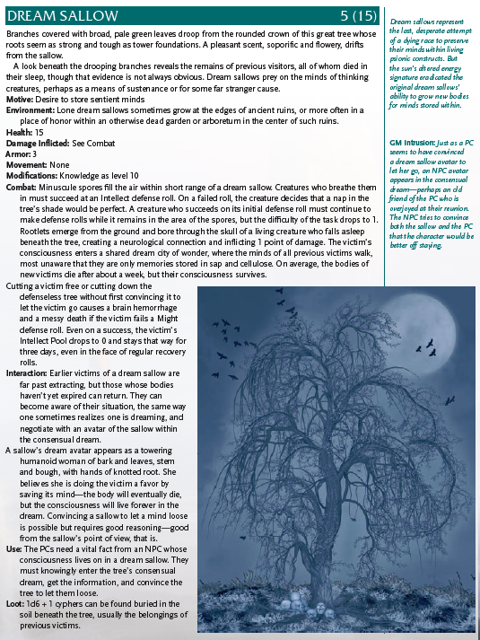

## Nibovian Companion

